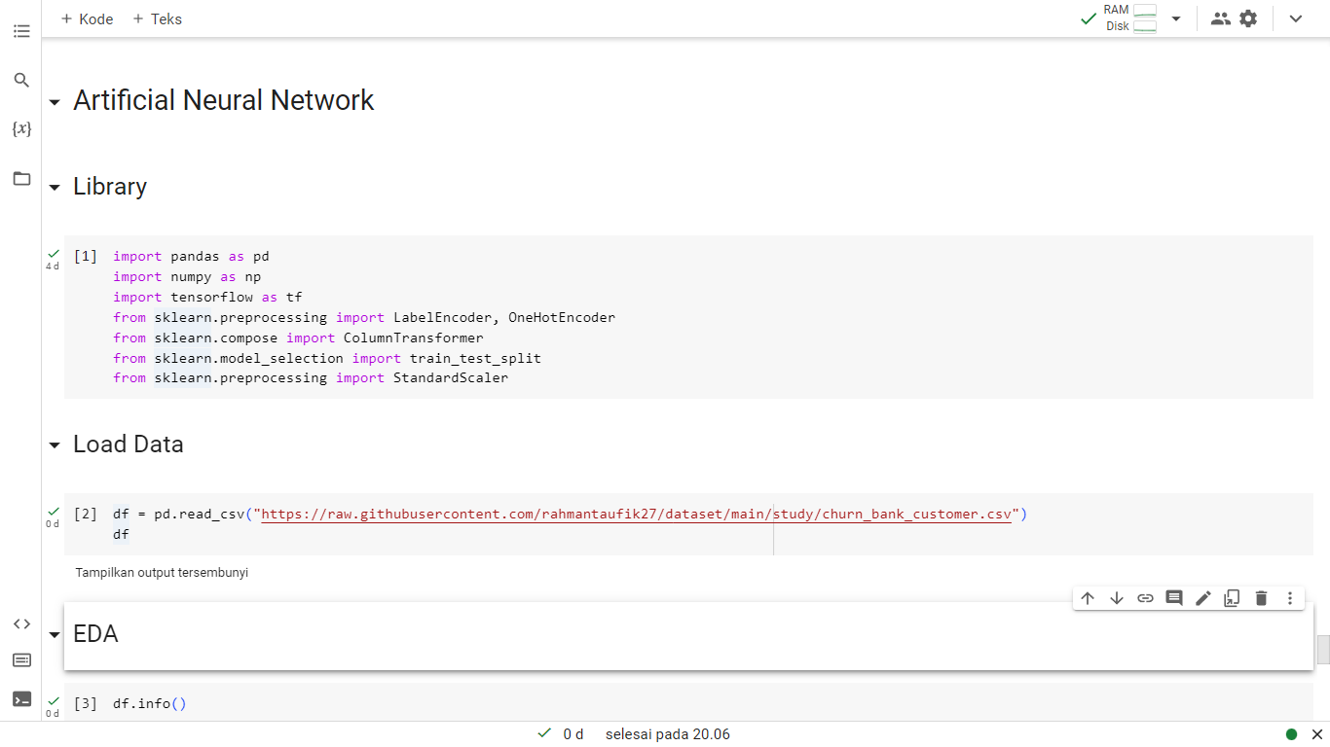

<https://raw.githubusercontent.com/rahmantaufik27/dataset/main/study/churn_bank_customer.csv>

